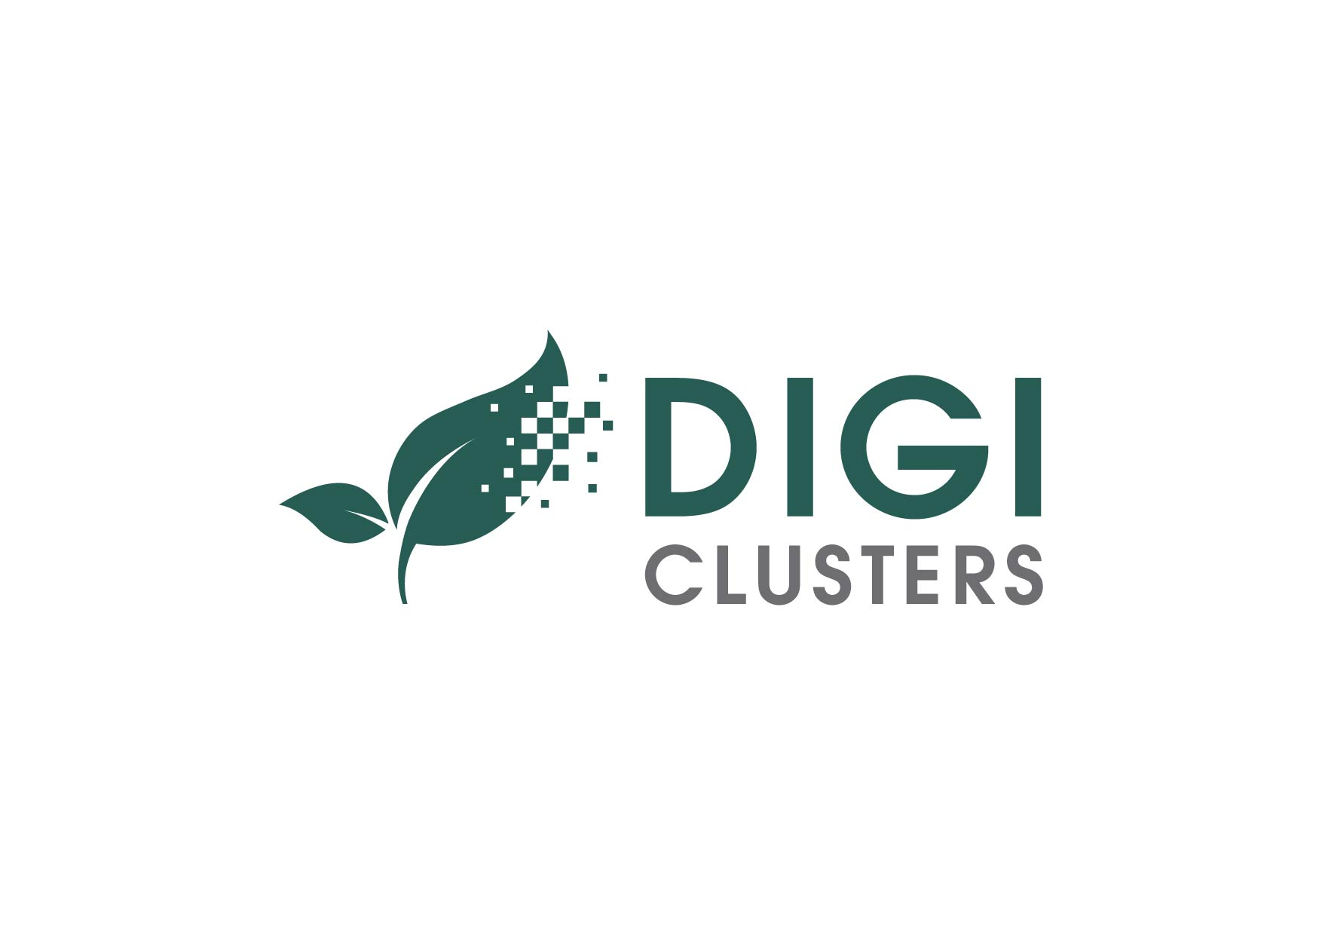
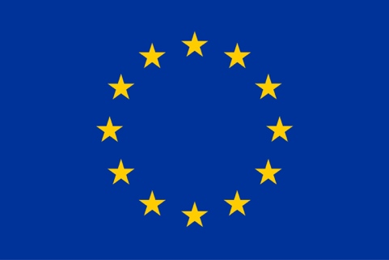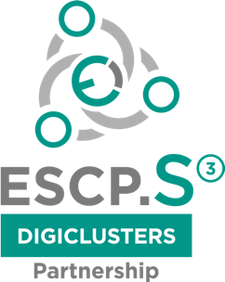

PROJECT
“ESCP S3 for speeding up industrial modernization of Agrofood packaging sectors towards Industry 4.0 and digital transformation by Cluster-Facilitated X-Industry Hackathons —DIGICLUSTERS”
PROJECT No. 822095

The Grand Agreement was signed on 01/10/2018 by Executive Agency for Small and Medium-sized Enterprises (EASME) under the powers delegated by the European Commission and Latvian IT Cluster (LITC), and the following other beneficiaries: AgroBioCluster represented by Foundation UNIMOS (UNIMOS/ABC), Food Products Quality Cluster represented by Latvian Federation of Food Companies (LFFC/FPQC), OnGranada Tech City (ON GRANADA), SMART food cluster represented by Lithuanian Food exporters association (LITMEA/SFC), Association of Lithuanian Printing Industries (LISPA), Lithuanian Innovation Center (LIC). The grant is awarded for the action entitled ‘ESCP S3 for speeding up industrial modernization of agrofood packaging sectors towards Industry 4.0 and digital transformation by Cluster-Facilitated X-Industry Hackathons — DIGICLUSTERS’.
The main objectives of the DIGICLUSTERs project are:
- To support setting-up the European Strategic Cluster Partnership for smart specialization investments (ESCP-S3)
- To foster the collaboration between enterprises, especially SMEs and their interactions with technology centers within the cluster and across regional and sectoral silos towards generating joint actions and investment projects in common smart specialisation priority areas linked to industrial modernisation and to help improving their business environment
- To speed up industrial modernization by bringing together clusters, regional authorities and technology centers and facilitate the generation of a pipeline of joint collaboration and innovation projects
- To implement joint activities with a view to mobilise interregional collaboration and investments of industry actors, notably SMEs, and provide related business, technology and growth support services
- To strengthen and facilitate linkages between clusters, technology centers and regional authorities in order to link specialized ecosystem and create favorable environment for innovations to accelerate industrial modernization
- To entrepreneurially discover new and strategic forms of interregional cooperation between and B2B with European partners to help SMEs incorporate new technologies and digital innovations and trigger collaboration aimed at joint investments
- To improve the visibility of the consortium, its partners and affiliates at European level, building and shaping positive image of involved clusters, SMEs, technology centers and regional governments

Project duration: The duration of the action will be 18 months as of 01/10/2018
The project is funded by the European Union’s COSME Programme.
The content of this document represents the views of the author only and is his/her sole responsibility; it cannot be considered to reflect the views of the European Commission and/or the Executive Agency for Small and Medium-sized Enterprises (EASME) or any other body of the European Union. The European Commission and the Agency do not accept any responsibility for use that may be made of the information it contains.

